|  |
| --- |
| **Genesee Valley Central School** |
| DJI Phantom I Quick Start Flight Manual |
| How to Fly and How it Works |
|  |
| **Jake R. Slaght** |
| **April 25, 2015**  **Amended May 4, 2015** |

# Abstract

A detailed guide of how to configure and fly the DJI Phantom I drone. This guide also contains the Quick Start guide within its documentation. Regulations of the FAA have been enclosed in regards to the how and what is required of the pilot to fly the drone.

Table of Contents

Abstract 1

Table of Figures 4

Introduction 5

Federal Aviation Agency (FAA) Regulations 6

Uses for GVCS 7

Academic Uses 7

Athletic Uses 7

Maintenance Uses 7

“Deconstruction” of the DJI Phantom I and Controller 8

The ‘Quick’ Guide Provided by DJI 8

The DJI Phantom I Drone 9

The Controller 10

The Camera 10

Pre-Flight 11

During Flight 12

Troubleshooting 13

Using the GoPro Camera 14

Appendix A: Pre-Flight Checklist 15

Night before Flight Day 15

Day of the Flight 15

At Location of Flight 16

Appendix B: Operating Drone during Flight 19

Setting a Home Point (HP) 21

To Change a Home Point during Flight 21

Setting and Using Course Lock (CL) Initially for Flight 21

To reset CL during Flight 21

How to Use Home Lock (HL) 22

Appendix C: LED/Sound Error Codes 23

Appendix D: NAZA-M Assistant Software 25

Hooking up the Drone to the Laptop 25

Configuring the Intelligent Orientation (IOC) Settings 29

Appendix E: Quick Guide for the GoPro Applications (Android and Apple) 30

Turning on the camera for mobile device control 30

To connect to the camera’s wireless network via an Android device 30

To connect to the camera’s wireless network via an Apple device 30

Using the Application 31

Images and Recordings can be viewed from the GoPro Application with control of the camera 31

Images and Recordings can be viewed from a computer 31

Appendix F: Advanced Techniques 32

Flying Curves 32

Regaining Control of the DJI Phantom while in the Air after a Fail Safe was initiated 32

Works Cited 33

QUICK START FLIGHT GUIDE 34

Pre-Flight Checklist 35

Operating Drone during Flight 39

Quick Guide for the GoPro Applications (Android and Apple) 43

LED/Sound Error Codes 45

# Table of Figures

Figure 1: Parts Provided 8

Figure 2: The Drone without camera mounted 9

Figure 3: The Drone with camera mounted 9

Figure 4: The Drone LED display shown 9

Figure 5: The Controller 10

Figure 6: Proper Connection of battery to charger 15

Figure 7: Horizontal Setup of the Calibration Dance -- Yellow Light Revealed 16

Figure 8: Horizontal Holding, showing hand positioning 17

Figure 9: Starting the vertical calibration 17

Figure 10: Vertical holding -- showing arms to drone position 17

Figure 11: Starting motors 19

Figure 5: The Controller 19

Figure 31: 3D Axis 20

Figure 12: Throttle Down -- Motor Kill Switch 21

Figure 13: LED Codes 23

Figure 14: Transmitter, ESC, and Compass Errors 23

Figure 15: Inside of battery hatch revealing cables 25

Figure 16: USB connected drone to laptop, controller turned on 25

Figure 17: Drone attached to laptop with battery 26

Figure 18: NAZA-M Splash Screen 26

Figure 19: NAZA-M Overview Screen 27

Figure 20: Controller Settings 27

Figure 21: Failsafe Settings 28

Figure 22: Battery Settings 28

Figure 23: IOC Settings Screen 29

Figure 24: Enable Wireless on GoPro Camera 30

Figure 25: Proper Connection of battery to charger 35

Figure 26: Horizontal Setup of the Calibration Dance -- Yellow Light Revealed 36

Figure 27: Horizontal Holding, showing hand positioning 37

Figure 28: Starting the vertical calibration 37

Figure 29: Vertical holding -- showing arms to drone position 37

Figure 30: Starting motors 39

Figure 5: The Controller 39

Figure 31: 3D Axis 40

Figure 32: Throttle Down -- Motor Kill Switch 41

Figure 33: Enable Wireless on GoPro Camera 43

Figure 34: LED Codes 45

Figure 35: Transmitter, ESC, and Compass Errors 45

# Introduction

The DJI Phantom I drone and GoPro Hero 3+ Camera purchased by the Genesee Valley Central School District (henceforth shortened to GVCS) has introduced a new level of technology to be introduced into the widely successful technological expansion of existing projects and technologies used by the school district thus far. The drone is capable of allowing a multitude of departments and students use it from a variety of potentional options within a secure and safe environment with strict supervision of well trained staff members of use in the drone’s operations.

The drone’s capabilities in the classroom allows the students and staff to dive head first into an emerging field only seen by highly trained professionals and allows them to gain an intimate understanding and a growing inspiration of the level of technique give for Aerial Photography.

The practical uses of showing mathematical equations to students allows for a better understanding of the information by placing it into a real world application allowing the students to take the information and retain it with a realistic understanding.

The company shipped guide provided little information and what was gathered by research, trial and error, and YouTube videos has been compiled and place within this document for and easy to access and read manual for use of the drone.

This document contains appendices for pre-flight, flight, camera use, NAZA-M software, and troubleshooting.

For Basic Quick Start instructions please utilize *Appendices A, B, C,* and *E*.

For more advanced techniques please see *Appendix F*.

# Federal Aviation Agency (FAA) Regulations

Before continuing on with the uses and the details of the document, there are a few things to bear in mind when reading this document.

The FAA requires that all flight time be done safely in regards to people, buildings, and animals. All flying must be done visually via line of sight, meaning that the camera cannot be used to maintain visual contact with the drone. This means that sufficient lighting and timing must be taken into consideration when flying the DJI Phantom I.

Please see *Appendices A* and *B* for detailed instructions of how to setup and fly the drone.

# Uses for GVCS

Drone usage for the school district can be used for several purposes: maintenance needs, educational lessons, and athletic training sessions. The only use currently sanctioned for use is the academic uses, the others listed as potential uses with permission and strict guidelines put into place to adhere to.

### Academic Uses

In the realm of academia the drone can be utilized in teaching classes on aerial photography techniques training and mathematics formulas (such as the quadratic equation). These advanced techniques in photography lessons can be used to teach the students how to catch a good idea of how to obtain a ‘bird’s eye view’ which are used in the Geology and Archeology fields (Mason).

In the realm of mathematics lessons the drone would be able to include real life applications of the quadratic formula, thus making the lesson more entertaining, engaging, and easier to remember the information taught. The quadratic formula is used to determine the path of a ball that is thrown or the placement of cables on a suspension bridge to thwart gravity’s pull. (Institute)

### Athletic Uses

Athletic departments can utilize the drone in regards to practices with explicit parental, board of education, and students’ permission. The drone’s aerial based video recording would allow coaches and athletes to see their weaknesses and strengths from a viewpoint similar to the Madden sports games commonly played by students on any number of gaming platforms. (Keilman)

This would require several heavy restrictions in regards to where it can be flown, how high it can be flown, the battery usage, time of day, and a direct understanding of all parties involved. As of right now, this is not recommended as a possible use for the Phantom I at the school district’s level.

### Maintenance Uses

A maintenance team could feasibly use the drone to video record and photograph locations that would be deemed hard to reach or unsafe to place a person on. The uses are endless though: checking for leaks, sagging roof, burst pipes, ventilation systems in question, unsafe ledges, or clogged rainfall systems. (Mason)

Currently this format of use would require line of sight control of the drone as is deemed necessary by the Federal Aviation Agency and therefore would place the safety of the pilot in question and is currently also an unfit way for the drone to be used currently.

# “Deconstruction” of the DJI Phantom I and Controller

The DJI Phantom I drone comes with the drone, built-in firmware installed, a RC controller, a battery, a wall charger for the drone battery, extra propellers, the NAZA-M software package to ensure proper configuration of the drone for flight use, and a quick user guide. The drone does come pre-configured out of the box to be flown immediately, but it advised to take into consideration the use of the NAZA-M software package provided and ensure all firmware is updated.

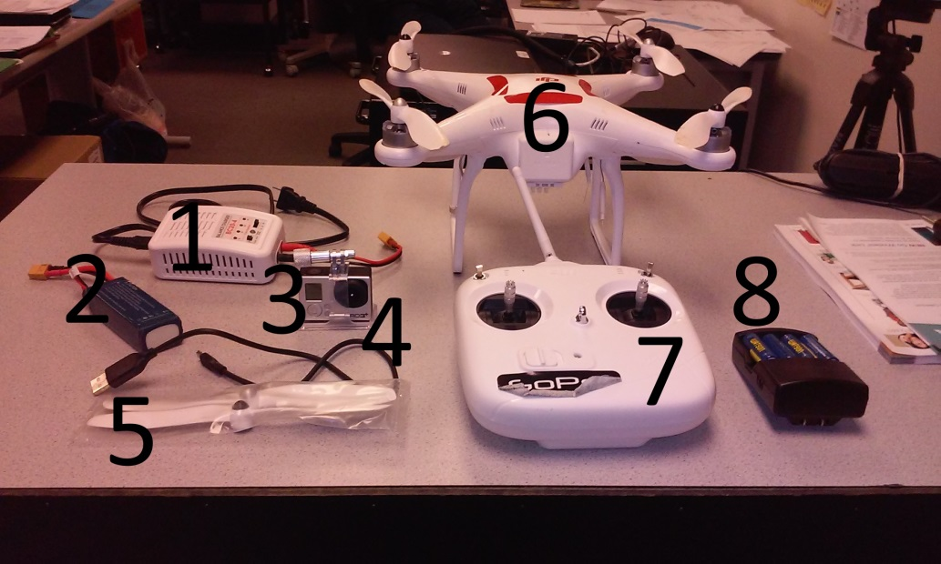

Figure : Parts Provided

Contents Shown: 1. Wall Charger for Drone Battery; 2. Drone battery; 3. GoPro Camera Hero 3+*; 4. USB cable for camera*; 5, Extra propellers; 6. DJI Phantom I drone; 7. RC Controller; 8. Controller batteries and wall charger*.

*NOTE: Sold Separately.

(source: Author)

### The ‘Quick’ Guide Provided by DJI

A quick note on this guide, it is inadequate in regards of how to fly or operate the drone and utilize the NAZA-M software provided. The guide does provide a quick guide to the troubleshooting LED lights as a reference sheet. Please see *Appendix C* for that chart as well as explanation.

Most of the information provided in this guide is produced from extensive trial-and-error methodology, extensive researching via Google Search, Drone Enthusiast forums, and YouTube video searches.

It is highly recommended to append any information provided within this documentation with further found research as necessary.

For extensive and detailed use of the NAZA-M software please consult *Appendix D*.

### The DJI Phantom I Drone

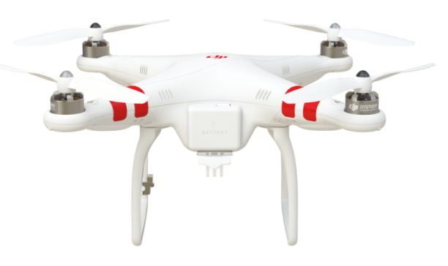

Figure : The Drone without camera mounted

(source: http://www.dji.com/product/phantom/feature)

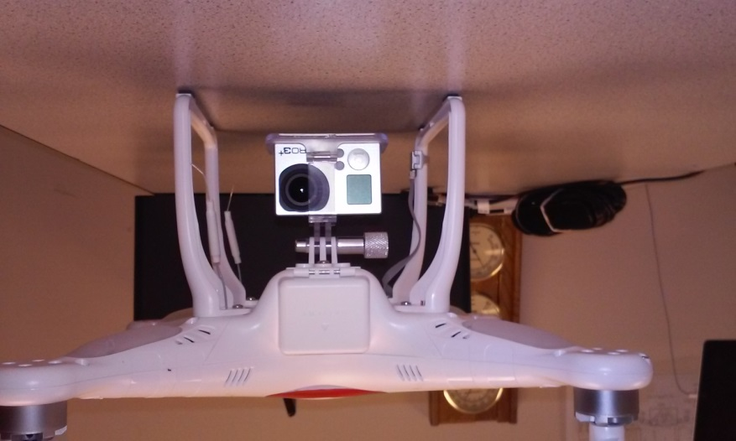

Figure : The Drone with camera mounted

(source: Author)

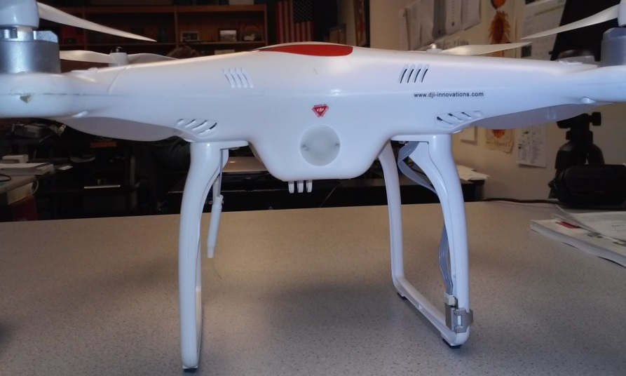

Figure : The Drone LED display shown

(source: Author)

This drone is classified as an Unmanned Aircraft System – henceforth known in this document as an UAS – by the Federal Aviation Agency (Administration).

The drone itself is a quadcopter, meaning is has four individualized motorized rotors. Each rotor is powered by an individually powered motor that adjusts speed to allow for the flying forward, backwards, up, down, left, and right of the drone.

The landing gear is a simple set of ‘legs’ that protect the main body of the drone and therefore the electronic equipment housed inside.

### The Controller

The controller consists of dual analog system used to control the drone’s flight operations and two toggle switches used for GPS based systems and GPS/Compass calibration setup.

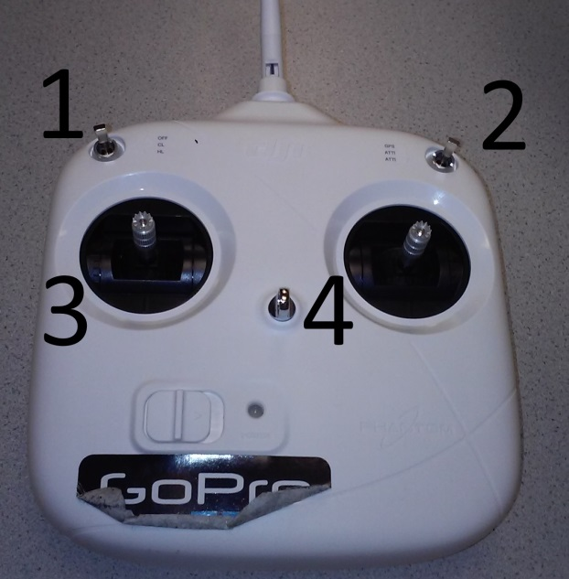

Figure : The Controller

Contents Shown: 1. HomeLock/CourseLock toggle; 2. GPS/ATTI/ATTI toggle; 3. Throttle; 4. Directional.

(source: Author)

The controller is pretty self-explanatory for use. Throttle controls the altitude of the drone giving it lift. The directional means the direction in which the pilot wants to move the drone: forward, backwards, left, or right. The controller takes 4 AA batteries, Figure 1, the item marked 8 shows the batteries housed in their charger. The batteries are placed within the controller on the underside, image not taken

### The Camera

Shown in Figure 1, the camera is a GoPro Hero 3+ and is used to take high-definition photos and videos. Though capable of taking live-feed footage and streaming it to a website, this is not recommended due to the technical difficulties with the Hero 3+ and does not affect the use of the camera in this circumstance.

# Pre-Flight

The pre-flight setup for the drone is a preventative setup allowing for a more satisfying and enjoyable flight experience. There is no mistake that being prepared is a major component of life and drone flight is no exception. *Appendix A* goes into the step by step setup that works well for the school’s currently owned drone.

*Appendix D* is also important to take into consideration every so often for the pre-flight checklist to check the configuration, firmware for the controller and the drone, as well as the occasional run through of the IOC setup, failsafe mechanism with effect of a low charged battery.

Some of the pre-flight setup is done during the day of the flight: double checking of weather conditions, calibration of the compass and GPS systems of the drone. Any errors thrown at this time can be examined and resolved by taking a look at *Appendix C*.

By following the pre-flight setup issues with failure to sync the controller to the drone, drone battery low error code, or no power to the controller can be resolved beforehand and therefore not occur.

*Appendix E* allows for thorough control of the camera and that also plays a part in the current setup of the pre-flight allowing for configuration of the proper devices, installation and gaining of camera control via said device, as well as maintain full access to the camera via it’s wireless network settings being inputted and the camera and device are fully powered allows for a more pleasant experience and more opportunities to take images and videos during flight.

# During Flight

Flight control needs to be taken cautiously as the guide from DJI failed to even acknowledge how to start the flight protocols as well as the setup of the drone’s failsafe protocols and low voltage situations this guide is meant to fill in any gaps that occur.

The quick start portion of this guide contains the how to start the flight control, as well as the setting up of the Intelligent Orientation Control system needed for Home Lock and Course Lock functionality via the NAZA-M software (see *Appendix E*).

Taking heed of the FAA regulations for flying a drone must be taken into serious consideration when flying the drone, a line of sight is required at all times, the pilot should not be controlling the wireless device’s camera taking functions well at the same time as flying due to the multi-tasking removing attention from the direction, speed, and altitude. This also includes any and all audio/LED based error codes that may be emitted at any time (see *Appendix C* for error codes).

# Troubleshooting

Just like with any technological devices troubleshooting is an important part of the system of control and integrity of the device in question. Due to the nature of the drone and the FFA regulations most of the error codes created by the creators of the Phantom I were done via LED displays on the drone itself as well as audio beep codes not far off from a computer’s beep codes for error codes.

*Appendix C* is the primary source of the noted errors deemed important by DJI a note should be made that this list is far from extensive and their guide provides no solutions. Research is recommended in due case that any of the errors have not yet been given a solution to. Currently all research done for troubleshooting and the filling out of this document has been done through trial and error runs and extensive YouTube searches looking for specific videos, any of the utilized videos and documents have been cited in the Works Cited with links provided.

# Using the GoPro Camera

Using the camera well attached to the drone is required to be done by a secondary person with a mobile device. Due to FAA regulations require full attention and line of sight conditions for flying the pilot is unable to attend to the necessitates of camera capabilities with the current system provided by the school at this time.

The camera is a lightweight GoPro Hero 3+ Black Edition that is capable of three basic styles of photography: single shot, photo burst, and recording in a wide screen HD setting. The multitude of photography capabilities allows for the person handling the camera controlling device a variety of styles they can take images with. Not all functionality via the mobile application has been determined at the time of this documentation.

*Appendix E* and the Quick Start Guide will have information on how to setup and use the camera via the application.

As a note multiple devices can control the camera at one time allowing for a variety of camera shots to be taken, however if one device’s user selects the power button icon the camera shuts off for all devices.

# Appendix A: Pre-Flight Checklist

The pre-flight checklist is important as most of the flight related issues can be handled before a flight demonstration.

### Night before Flight Day

1. Ensure the Weather is going to be flight capable
   1. High winds, cold temperatures, low visibility and precipitation of any sort will halt flying the DJI Phantom immediately.
2. Plug in battery into wall charger and allow it to charge overnight.
   1. Plug in the wall charger into the wall and set the settings as mentioned below.
   2. Settings on the charger should be LiPo and 3A
   3. Plug in the Orange plug of the battery into the charging wire of the battery.
   4. Plug in the four pin cable into the side of the battery charger in the proper location

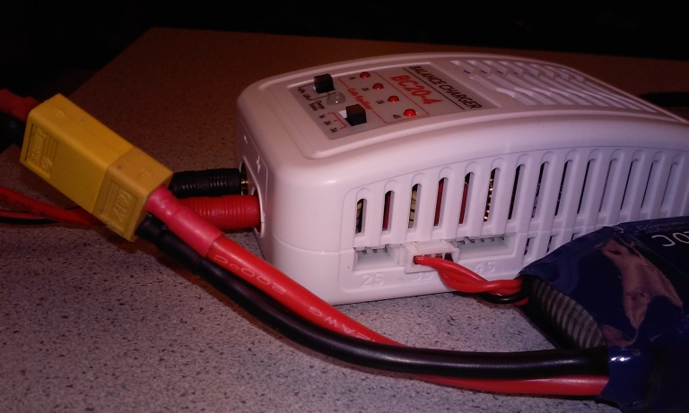

Figure : Proper Connection of battery to charger

(source: Author)

1. Plug in charger for controller batteries into wall and place batteries in it.
2. Plug and Charge the iPad or Android device being used to control the GoPro Camera
3. Turn on a laptop and ensure it will remain logged in and on.
4. Using the cable provided for the GoPro Camera Hero 3+ Black Edition. Plug the camera in and allow it to charge.

***\*NOTE* Allowing the battery to charge overnight ensures full charger for a morning flight.***

***\*NOTE – If using 2 batteries* The morning of the flight, unplug the first battery and plug in the second battery in the same fashion.***

### Day of the Flight

1. Make note of current weather conditions
   1. If weather is bad postpone to the afternoon or the following day.
      1. Bad weather constitutes as rain, snow, high winds
2. Unplug and bring along all the charged batteries and camera.
3. Bring the Drone, iPad (or Android device) being used for the GoPro Camera Application, Controller, and the lightweight camera mount.
4. Install the controller batteries now, do not install drone battery or turn on the controller until at location
5. Locate a wide open area with minimal buildings, electrical, or metal based structures as they will interfere with the configuration and calibration of the drone.
6. Refer to *Appendix E* for use of the camera

### At Location of Flight

1. Place the drone on flight level ground and place the controller down as well.
2. Turn on the controller
   1. The controller must be on prior to powering up the drone for the drone and the controller to sync correctly to one another
3. Put camera in mount and install mount onto the drone so it faces out.
   1. Camera will face out underneath the battery hatch of the drone

**\*IMPORTANT* The camera facing out is the nose of the Drone. If not using camera the default nose setting it the battery hatch**

1. Install battery into drone
   1. The lights will come on with an accompanying sound.
   2. If issues persist – Lights flashing red or beep codes please look at *Appendix C*.
2. Make sure all switches on the drone are positioned correctly
   1. The HomeLock/CourseLock switch on the left side should be set to ‘Off’
   2. The GPS/ATTI/ATTI switch on the right should be set to ‘GPS’
3. On the controller toggle the GPS/ATTI/ATTI switch 6 to 10 times until the LED light on the drone is a solid yellow-orange (here on out will be declared ‘Yellow’) and the toggle switch is on GPS
   1. This step should be done slowly to ensure switch ends correctly, otherwise repeat until correct
4. Perform the ‘Calibration Dance’ Ritual
   1. Pick up the Drone carefully so it is still horizontally positioned with arms out.

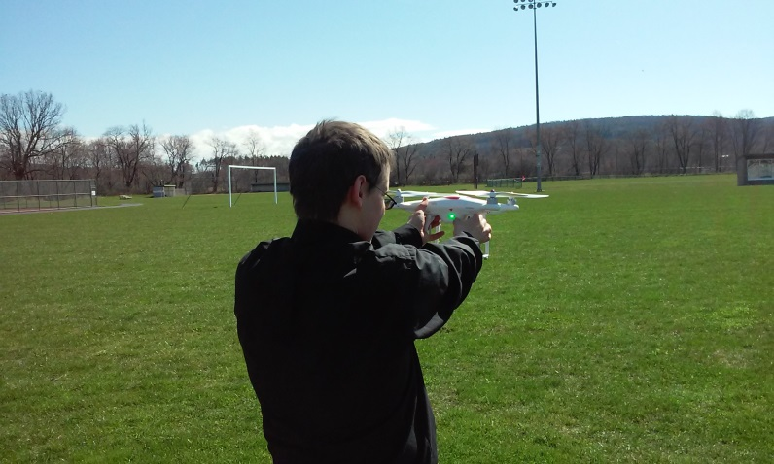

Figure : Horizontal Setup of the Calibration Dance -- Yellow Light Revealed

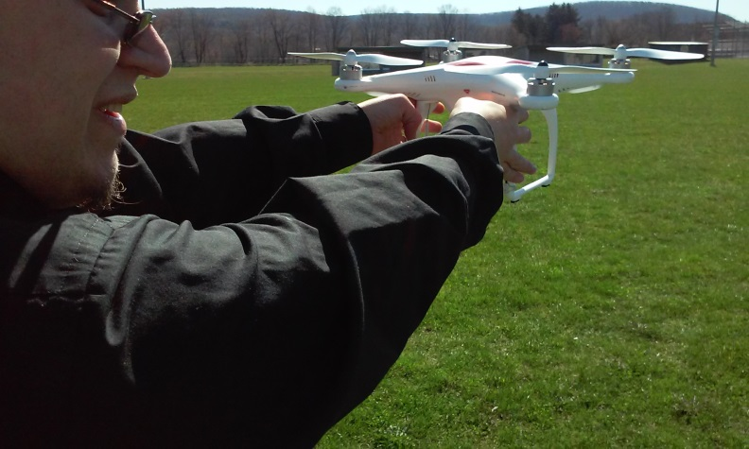

Figure : Horizontal Holding, showing hand positioning

* 1. Very slowly walk in a counter-clockwise circle until the LED light on the drone turns a solid Green
  2. Turn the drone vertically holding the legs and the LED light is facing up.

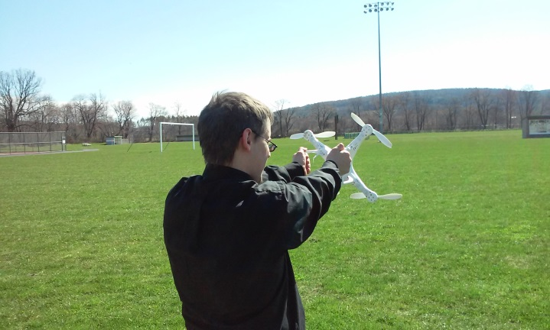

Figure : Starting the vertical calibration

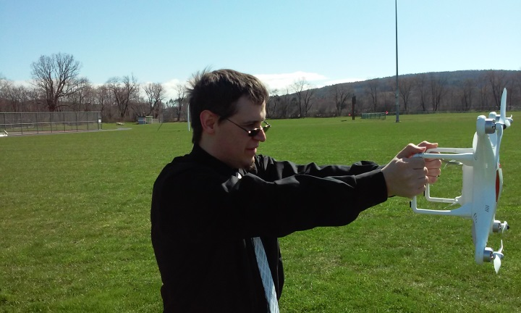

Figure : Vertical holding -- showing arms to drone position

* 1. Very slowly walk in a counter-clockwise circle until the LED light flashes yellow

1. Set down the drone and allow the GPS system and the satellites to sync.
   1. This step can take several minutes to complete, the light sequence is listed in *Appendix C*.
2. You are now ready for flying the DJI Phantom I drone
   1. Refer to *Appendix B* for Operating the Drone during Flight
3. Enjoy and Be Safe!

***\*NOTE* Video Guide of Pre-Flight Drone Operation provided, go to: [insert link]***

# Appendix B: Operating Drone during Flight

Once the Pre-Flight setup has been completed and the drone is ready to fly the steps below are fairly simple and probably the easiest to handle!

**\*IMPORTANT* See *Appendix E* in how to use the Camera**

1. Start the Motors
   1. Pushing both joysticks down in opposite outside corners works best
      1. Throttle down and to the left
      2. Directional down and to the right

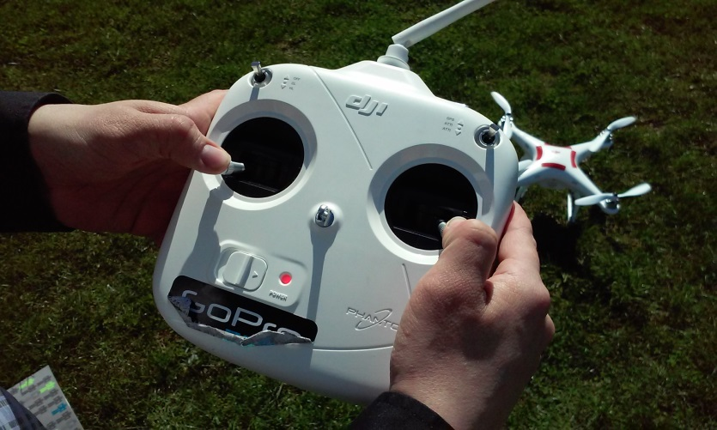

Figure : Starting motors



Figure : The Controller

Contents Shown: 1. HomeLock/CourseLock toggle; 2. GPS/ATTI/ATTI toggle; 3. Throttle; 4. Directional.

(source: Author)

* 1. Once motors start, release the joysticks so they return to the center
  2. Allow the motors and rotors to spin for several seconds
  3. If any sounds or the motors slow down and stop spinning please review *Appendix C*

1. Once motors are going without issues ready for flight
2. Slowly apply upward pressure to the Throttle
   1. The motors will make a lot of noise at this point – this is normal
   2. Continue to apply throttle until drone starts lifting off the ground.
   3. Once drone is off the ground, applying more pressure will send it up into the air higher

After the above steps, the following steps are more of how-to move the drone

***\*NOTE* The direction of flight is determined by the direction of the nose of the drone. If nose is facing towards the pilot, the directional orientation is reversed and the left and right spins on throttle are reversed. Drone facing left the directional orientation is rotated 90° to the left. Drone facing right the directional orientation is rotated 90° to the right. See Course Lock functionality below.***

1. To Hover: Release the throttle, the drone will remain in a hover state as long as the wind isn’t too strong. It may move slightly.
2. To turn the drone around in either the left or right along it’s z-axis (up and down): Push the throttle stick to the left or right.
3. To move forward or backwards along the y-axis: Push the directional stick forward or pull it back
4. To move left or right on the x-axis: Push the directional stick left or right.

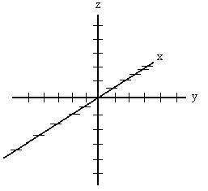

Figure : 3D Axis

*(source:* (deepimpact.umd.edu)*)*

1. To Land: Slowly pull the throttle down until the drone lands on the ground, keep the stick down, adjusting the directional stick as needed to keep the drone stable
   1. Keep the throttle stick pulled downward until the motors stop running.

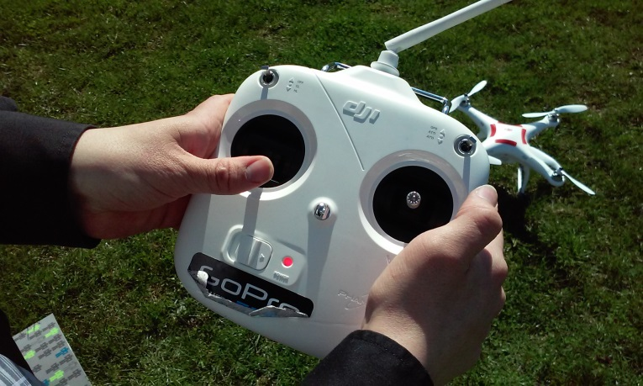

Figure : Throttle Down -- Motor Kill Switch

### Setting a Home Point (HP)

A home point is the location in which the drone will use as a home base for the Course Lock and Home Lock functions. The starting home point of any initial flight is the starting location of the controller. (Time, #7)

### To Change a Home Point during Flight

1. Find new location clear of pilot
2. Toggle CL/HL switch between CL and HL 5 times. (Time, #7)

### Setting and Using Course Lock (CL) Initially for Flight

Course Lock allows for the pilot to have the same directional control of the drone regardless of the nose’s physical pointing direction.

**\*IMPORTANT* CL can only be used within a 16 to 32 foot radius circle of the Home Point.**

To set the CL initially while in the field the pilot does the following:

1. With drone and controller off place the nose of the drone in the direction desired for forward.
2. Turn on the Drone and Controller in the fashion mentioned above
3. Allow GPS to sync to drone
4. Toggle the CL/HL toggle to CL and wait for the yellow flashing with green
5. CL is now set
6. To fly with CL now set toggle to off
7. Fly as normal

**\*IMPORTANT* Course Lock allows the pilot to use the same directional and spin directions of the throttle regardless of direction of the nose of the drone.**

*Source:* (Time, #5)

### To reset CL during Flight

With the drone in flight and the pilot wants to shift the directional controls for easier orientation between the controller and the drone

1. Toggle CL On and Off 5 times until a flashing green light appears.
2. Return the toggle to Off
3. Fly as normal

*Source:* (Time, #5)

### How to Use Home Lock (HL)

Home Lock allows for drone to return to the home. The location of the ‘home point’ is the location of the controller’s coordinates.

***\*NOTE\****

1. ***Home Lock is not for Failsafe control.***
2. ***HL is not automatic***
3. ***HL does not care about orientation of the drone, it will return towards the HP.***
4. ***HL only works outside of the CL range***

To use Home Lock the pilot would toggle the CL\HL to HL and pull down on the directional stick.

*Source:* (Time, #7)

**\*IMPORTANT* At any time the drone becomes out of the range of the controller, batteries run low on the drone the drone will enter a Fail Safe protocol which will send the drone back to the current home point.**

**\*IMPORTANT* If the pilot feels uncomfortable with the drone’s current flight patterns or loses sight of the drone see below about Home Lock**

***\*NOTE* The GPS location of the starting point is not 100% accurate due to the technology in use of the GPS system of the drone.***

***\*NOTE 2* To set Course Lock or Home Lock please see Appendix D on how to set the Intelligent Orientation Control settings in the NAZA-M software***

**\*IMPORTANT* See *Appendix F* for Advanced Techniques**

***\*NOTE* Video Guide of Drone Flight Operation provided, go to: [insert link]***

# Appendix C: LED/Sound Error Codes

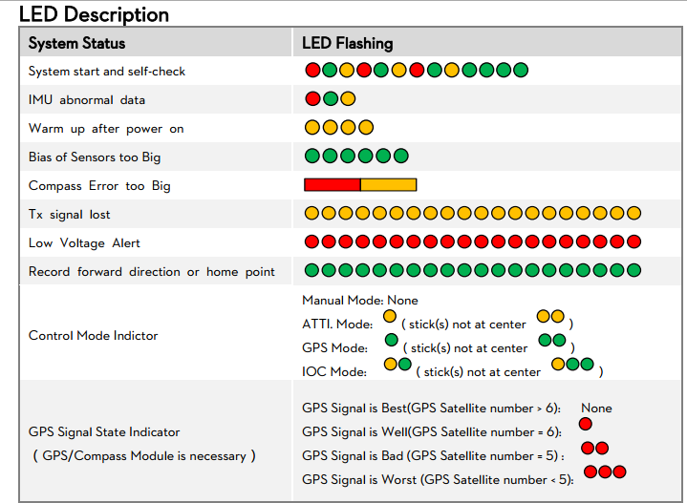

Figure : LED Codes

(source: DJI)

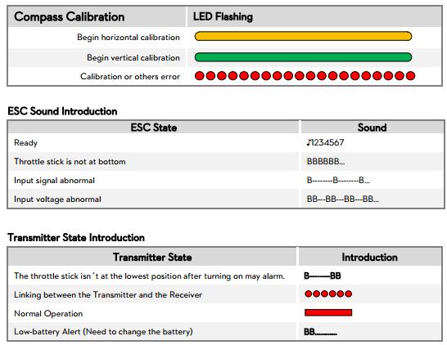

Figure : Transmitter, ESC, and Compass Errors

*(source: DJI)*

Figure 13 shows standard LED errors that can usually be prevented by following the Pre Flight Checklist in *Appendix A*.

Figure 14 are not all errors (such as the calibration LED, some of the Transmitter States, and the Ready of ESC Sounds) the rest can be fixed by moving the drone or following *Appendix A*.

# Appendix D: NAZA-M Assistant Software

To use the NAZA-M software the user will need to plug in the drone and have the remote tethered to the drone for proper configuration of the system.

### Hooking up the Drone to the Laptop

1. Inside the drone’s battery hatch is the battery adapter connection and a grey male USB port.

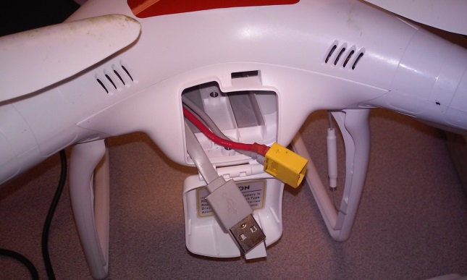

Figure : Inside of battery hatch revealing cables

(source: Author)

1. Using the included USB wire to connect the drone to a laptop, connect it to the laptop that houses the NAZA-M.
2. Turn on the remote to the controller

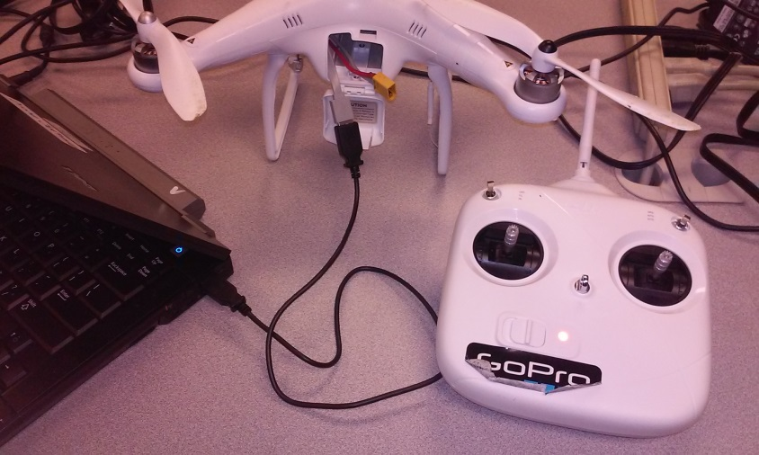

Figure : USB connected drone to laptop, controller turned on

(source: Author)

1. Install the battery into the drone
   1. Drone should chirp properly and then go quiet

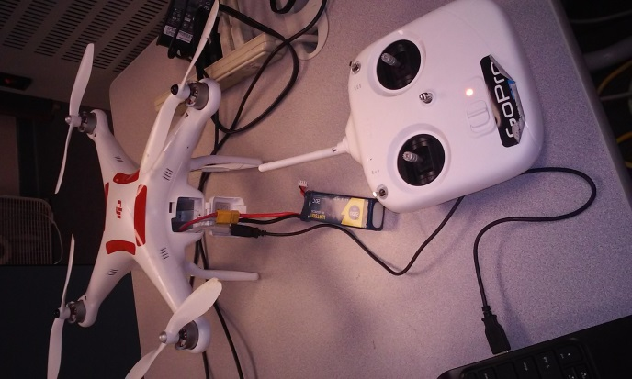

Figure : Drone attached to laptop with battery

(source: Author)

1. Open the NAZA-M software

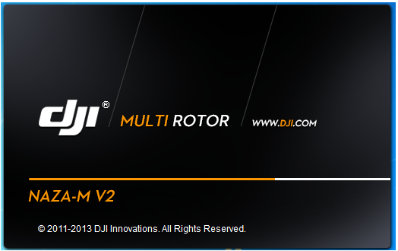

Figure : NAZA-M Splash Screen

(source: Author)

1. Upon boot up of the NAZA-M the user gets an over view of all settings

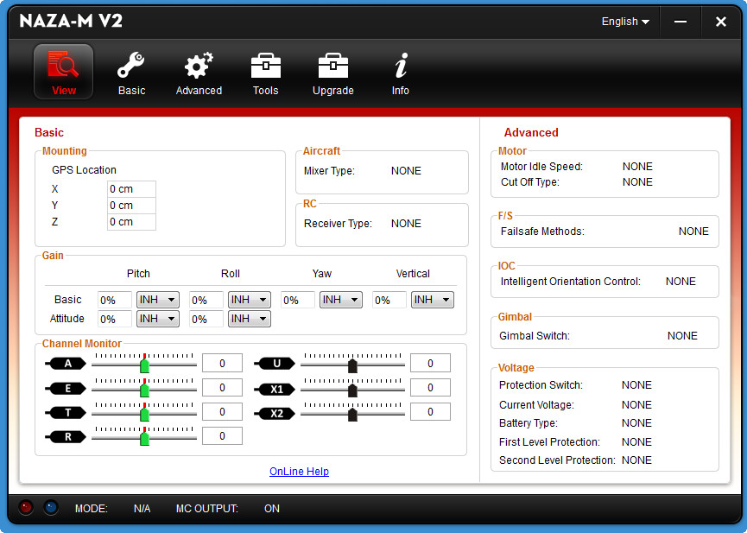

Figure : NAZA-M Overview Screen

(source: Informer (Informer))

1. The user can ensure the calibration of the controller for fine tuning control under the Basic Tab and RC
   1. In Figure 11 the following labels correlate to the following toggle switches and joysticks of the controller:
      1. A : Directional
      2. E: Directional
      3. T: Throttle
      4. R: Throttle
      5. U: GPS/ATTI/ATTI
      6. X1: HL/CL toggle
      7. X2: GPS/ATTI/ATTI toggle

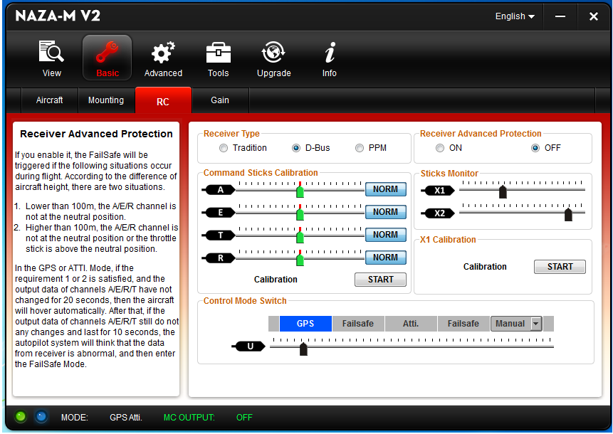

Figure : Controller Settings

(source: Author)

1. To set the Intelligent Orientation Control settings for Home Lock and Course Lock the user accesses the Advanced tab under To allow for the drone to return upon battery dying or the loss of controller communication the user accesses the Failsafe Settings under the Advanced Settings.
   1. This setting also plays hand in hand with the battery settings the user can locate under Advanced > Voltage

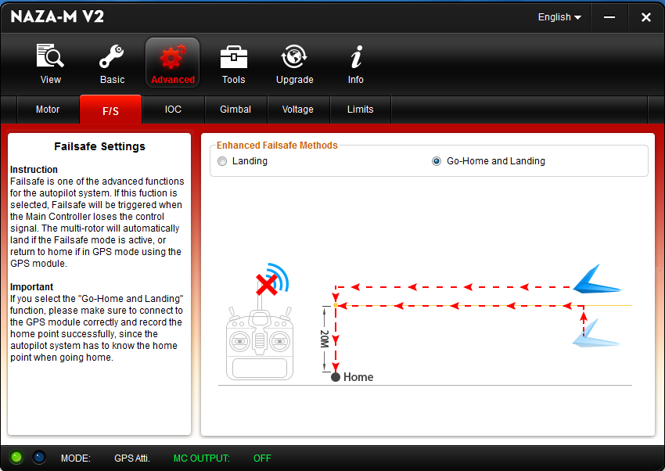

Figure : Failsafe Settings

*(source: Author)*

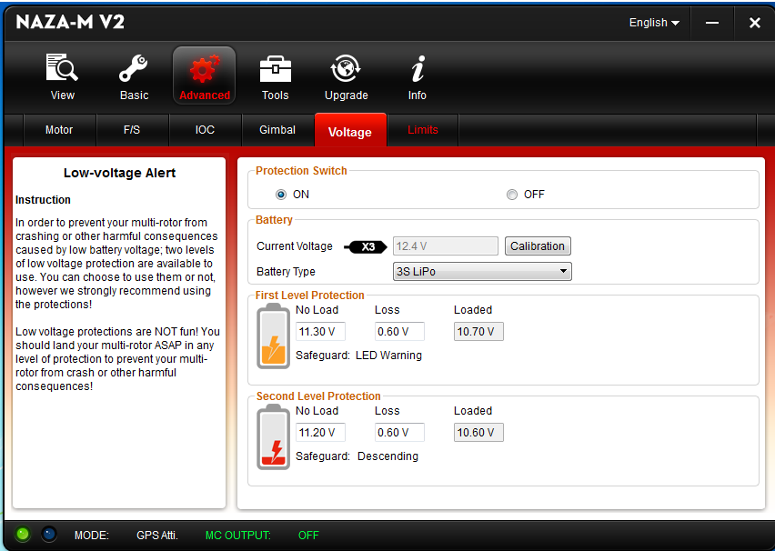

Figure : Battery Settings

(source: Author)

### Configuring the Intelligent Orientation (IOC) Settings

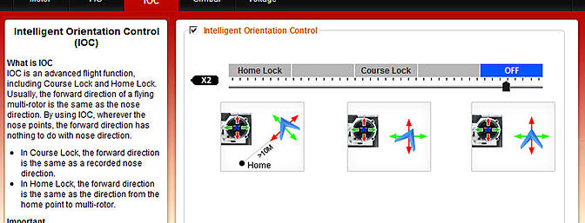

Figure : IOC Settings Screen

*(source:* (RCGroups)*)*

The IOC settings are required to utilize the Home Lock and Course Lock functions during flight usage. See *Appendix B* for Home Lock and Course Lock control.

The only step required to configure the IOC is to check the box for it at the top.

* The X2 indicated is the CL/HL toggle switch found on the controller, if toggled the slider will indicate the setting selected within the software.

# Appendix E: Quick Guide for the GoPro Applications (Android and Apple)

Using the GoPro application for either system is amazingly simple to do and is recommended to not be done by the pilot of the drone. The Application allows for a variety of photo shots to be taken and video recording to be handled as well. Both systems are exactly the same in use, but the device settings for Wi-Fi connection to the camera’s network are different.

### Turning on the camera for mobile device control

1. Ensure the camera is set to Wi-Fi access
   1. The camera will have a flashing blue light on front below its LED display
   2. If the blue light doesn’t flash push the black button on the left hand side until camera chirps and the light flashes

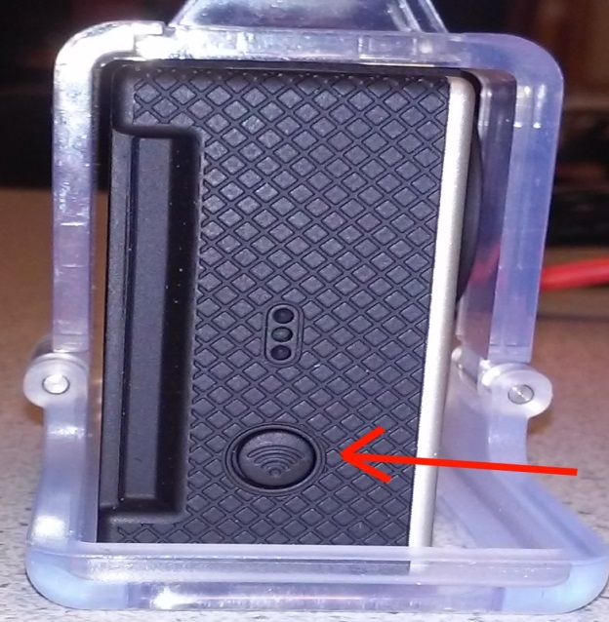

Figure : Enable Wireless on GoPro Camera

(source: Author)

* 1. The camera’s wireless network
     1. Network name is: *gopro_camera*
     2. The password is: jaguars1

### To connect to the camera’s wireless network via an Android device

1. Go to Applications -> Settings -> Select Wi-Fi -> Toggle Wi-Fi On -> Locate the camera’s network and select it -> if it prompts for the password input see above

### To connect to the camera’s wireless network via an Apple device

1. Go to Settings -> Wi-Fi -> Toggle on (if off)-> Locate the camera’s network and select it -> if it prompts for the password input see above
2. If camera’s network is not found: click ‘Other…’ -> input network name, Security will be WPA/WPA2 -> input password above -> Join

***\*NOTE* Once on the camera’s network access to the internet for any reason are denied due to no DNS or DHCP connection to the outside world***

***\*NOTE* Multiple devices can control the camera at one time allowing for a variety of camera shots to be taken, however if one device’s user selects the power button icon the camera shuts off for all devices.***

### Using the Application

Here the use of the application is exactly the same in regards to the device used.

1. Locate the GoPro Application
2. Select ‘Connect & Control’

Once in control the user can:

1. Turn the camera on and off by using the power button icon in the upper right hand corner.
2. Below the power button icon is the wireless strength and the camera’s battery
3. Switch the camera from single shot, photo burst, video, and time lapse photo located in the bottom right corner by the little wrench
   1. The starting setup is for video recording
4. Take pictures via the big red circle on the bottom center of screen
5. To view current images or videos available for viewing on the camera currently click the little grid symbol down in the bottom left hand corner.
6. The wrench in the bottom right hand corner is the camera’s settings
7. To see the camera’s current perspective (with a slight lag) one just needs to look in the center of the screen.

### Images and Recordings can be viewed from the GoPro Application with control of the camera

1. At the main menu of the Application Select ‘My GoPro Album’

### Images and Recordings can be viewed from a computer

1. With the Camera turned on using the provided USB cable
2. Go to the Camera in the File Explorer
3. Click DCIM
4. All images and videos will be listed in terms of date and time
   1. Double clicking your device’s acceptable file types to view images or videos.

# Appendix F: Advanced Techniques

This appendix concerns some of the more advance techniques the pilot can do when flying the drone

### Flying Curves

The ability to fly curves easily is a hard enough task to handle, however with the Home Lock and Course Lock settings the pilot can learn to fly curves with ease.

In order to fly curves:

1. Set a new Home Point to be away from the controller
2. Set CL to desired orientation
3. Fly beyond the CL radius from HP
4. Follow Home Lock directions in *Appendix B*
5. Once the drone enters CL radius it will immediately curve into the direction of the down directional of the CL set
6. Using the Throttle’s left or right spinning ability rotate the drone so it is pointed in whatever direction desired
7. As the drone turns in place it will continue to redirect in the backwards orientation of the CL

*Source:* (Time, #7, 2014)

### Regaining Control of the DJI Phantom while in the Air after a Fail Safe was initiated

Whenever the drone leaves the range of the controller, the battery is dying, or the controller is dead it will enter a Fail Safe protocol. The following steps only work when the drone regains range of the drone.

1. Turn off the controller – This initializes the Fail Safe protocol
   1. The drone’s LED will flash in accordance to the LED Error for loss of controller which can be found in *Appendix C*
2. Toggle the GPS\ATTI\ATTI setting to the first ATTI setting
3. Pull the Throttle down
4. Turn the controller back on
5. The controller’s power LED will flash several times and then go solid
6. Release the throttle
7. Control of Drone is regained.

**\*IMPORTANT* This technique should ONLY be done after several hours of training and in an open field**

*Source:* (Laur, 2013)

# Works Cited

(n.d.). Retrieved May 04, 2015, from deepimpact.umd.edu: https://s.yimg.com/fz/api/res/1.2/pBKWfhGz3eKQPy_033GuKQ--/YXBwaWQ9c3JjaGRkO2g9MjM1O3E9OTU7dz0yNTc-/http://deepimpact.umd.edu/webdings/icons/challenge_3DAxes.jpg

Administration, F. A. (2015, Febuary 17). *Unmanned Aircraft Systems (UAS) Frequently Asked Questions* . Retrieved Febuary 25, 2015, from Federal Aviation Administration: https://www.faa.gov/uas/faq/

DJI. (2013, September 25). *PHANTOM Quick Start Manual v1.7*. Retrieved April 29, 2015, from http://download.dji-innovations.com/downloads/phantom/en/PHANTOM_Quick_Start_Manual_v1.7_en.pdf

*Informer*. (n.d.). Retrieved Febuary 25, 2015, from http://img.informer.com/screenshots/4341/4341095_1.jpg

Institute, M. (2011). *Applications of Quadratic Functions*. Retrieved February 19, 2015, from Monterey Institute: http://www.montereyinstitute.org/courses/Algebra1/COURSE_TEXT_RESOURCE/U10_L2_T1_text_container.html

Keilman, J. (2014, October 24). *Drones used to capture high school football action*. Retrieved Febuary 26, 2015, from Chicago Times: http://www.chicagotribune.com/suburbs/elgin-courier-news/news/ct-high-school-football-drone-met-20141024-story.html#page=1

Laur, A. (2013, March 31). *DJI Phantom -Important ! How to Take Control in Air after Fail-Safe !!!* Retrieved April 29, 2015, from YouTube: https://www.youtube.com/watch?v=wI6fgmuk2rM

Mason, M. (n.d.). *Aerial Photography Principles and Applications*. Retrieved April 27, 2015, from Environmental Science.org: http://www.environmentalscience.org/principles-applications-aerial-photography

*Phantom 1 - Features | DJI*. (n.d.). Retrieved Febuary 20, 2015, from DJI: http://www.dji.com/product/phantom/feature

*RCGroups*. (n.d.). Retrieved Febuary 25, 2015, from http://static.rcgroups.net/forums/attachments/1/0/0/9/9/6/ai15841173-141-thumb-Asst8.jpg?d=1370651242

Time, T. T. (2014, May 19). *#5*. Retrieved April 29, 2015, from YouTube - #5 DJI Phantom Tutorial - IOC Course Lock (CL) Explained and Demostrated: https://www.youtube.com/watch?annotation_id=annotation_1577434411&feature=iv&src_vid=IYYVyRVGE-8&v=P9tncWssRns

Time, T. T. (2014, May 19). *#7*. Retrieved April 29, 2015, from YouTube - #7 DJI Phantom Tutorial - IOC Homelock (HL) Explained and Demostrated: https://www.youtube.com/watch?v=IYYVyRVGE-8

DJI PHANTOM I

# QUICK START FLIGHT GUIDE

Jake R Slaght

April 25 2015

Amended May 4, 2015

## Pre-Flight Checklist

The pre-flight checklist is important as most of the flight related issues can be handled before a flight demonstration.

#### Night before Flight Day

1. Ensure the Weather is going to be flight capable
   1. High winds, cold temperatures, low visibility and precipitation of any sort will halt flying the DJI Phantom immediately.
2. Plug in battery into wall charger and allow it to charge overnight.
   1. Plug in the wall charger into the wall and set the settings as mentioned below.
   2. Settings on the charger should be LiPo and 3A
   3. Plug in the Orange plug of the battery into the charging wire of the battery.
   4. Plug in the four pin cable into the side of the battery charger in the proper location



Figure : Proper Connection of battery to charger

(source: Author)

1. Plug in charger for controller batteries into wall and place batteries in it.
2. Plug and Charge the iPad or Android device being used to control the GoPro Camera
3. Turn on a laptop and ensure it will remain logged in and on.
4. Using the cable provided for the GoPro Camera Hero 3+ Black Edition. Plug the camera in and allow it to charge.

***\*NOTE* Allowing the battery to charge overnight ensures full charger for a morning flight.***

***\*NOTE – If using 2 batteries* The morning of the flight, unplug the first battery and plug in the second battery in the same fashion.***

#### Day of the Flight

1. Make note of current weather conditions
   1. If weather is bad postpone to the afternoon or the following day.
      1. Bad weather constitutes as rain, snow, high winds
2. Unplug and bring along all the charged batteries and camera.
3. Bring the Drone, iPad (or Android device) being used for the GoPro Camera Application, Controller, and the lightweight camera mount.
4. Install the controller batteries now, do not install drone battery or turn on the controller until at location
5. Locate a wide open area with minimal buildings, electrical, or metal based structures as they will interfere with the configuration and calibration of the drone.
6. Refer to *Appendix E* for use of the camera

#### At Location of Flight

1. Place the drone on flight level ground and place the controller down as well.
2. Turn on the controller
   1. The controller must be on prior to powering up the drone for the drone and the controller to sync correctly to one another
3. Put camera in mount and install mount onto the drone so it faces out.
   1. Camera will face out underneath the battery hatch of the drone

**\*IMPORTANT* The camera facing out is the nose of the Drone. If not using camera the default nose setting it the battery hatch**

1. Install battery into drone
   1. The lights will come on with an accompanying sound.
   2. If issues persist – Lights flashing red or beep codes please look at *Appendix C*.
2. Make sure all switches on the controller are positioned correctly
   1. The HomeLock/CourseLock switch on the left side should be set to ‘Off’
   2. The GPS/ATTI/ATTI switch on the right should be set to ‘GPS’
3. On the controller toggle the GPS/ATTI/ATTI switch 6 to 10 times until the LED light on the drone is a solid yellow-orange (here on out will be declared ‘Yellow’) and the toggle switch is on GPS
   1. This step should be done slowly to ensure switch ends correctly, otherwise repeat until correct
4. Perform the ‘Calibration Dance’ Ritual
   1. Pick up the Drone carefully so it is still horizontally positioned with arms out.



Figure : Horizontal Setup of the Calibration Dance -- Yellow Light Revealed



Figure : Horizontal Holding, showing hand positioning

* 1. Very slowly walk in a counter-clockwise circle until the LED light on the drone turns a solid Green
  2. Turn the drone vertically holding the legs and the LED light is facing up.



Figure : Starting the vertical calibration



Figure : Vertical holding -- showing arms to drone position

* 1. Very slowly walk in a counter-clockwise circle until the LED light flashes yellow

1. Set down the drone and allow the GPS system and the satellites to sync.
   1. This step can take several minutes to complete, the light sequence is listed in *Appendix C*.
2. You are now ready for flying the DJI Phantom I drone
   1. Refer to *Appendix B* for Operating the Drone during Flight
3. Enjoy and Be Safe!

***\*NOTE* Video Guide of Pre-Flight Drone Operation provided, go to: [insert link]***

## Operating Drone during Flight

Once the Pre-Flight setup has been completed and the drone is ready to fly the steps below are fairly simple and probably the easiest to handle!

**\*IMPORTANT* See *Appendix E* in how to use the Camera**

1. Start the Motors
   1. Pushing both joysticks down in opposite outside corners works best
      1. Throttle down and to the left
      2. Directional down and to the right



Figure : Starting motors



Figure : The Controller

Contents Shown: 1. HomeLock/CourseLock toggle; 2. GPS/ATTI/ATTI toggle; 3. Throttle; 4. Directional.

(source: Author)

* 1. Once motors start, release the joysticks so they return to the center
  2. Allow the motors and rotors to spin for several seconds
  3. If any sounds or the motors slow down and stop spinning please review *Appendix C*

1. Once motors are going without issues ready for flight
2. Slowly apply upward pressure to the Throttle
   1. The motors will make a lot of noise at this point – this is normal
   2. Continue to apply throttle until drone starts lifting off the ground.
   3. Once drone is off the ground, applying more pressure will send it up into the air higher

After the above steps, the following steps are more of how-to move the drone

***\*NOTE* The direction of flight is determined by the direction of the nose of the drone. If nose is facing towards the pilot, the directional orientation is reversed and the left and right spins on throttle are reversed. Drone facing left the directional orientation is rotated 90° to the left. Drone facing right the directional orientation is rotated 90° to the right. See Course Lock functionality below.***

1. To Hover: Release the throttle, the drone will remain in a hover state as long as the wind isn’t too strong. It may move slightly.
2. To turn the drone around in either the left or right along it’s z-axis (up and down): Push the throttle stick to the left or right.
3. To move forward or backwards along the x-axis: Push the directional stick forward or pull it back
4. To move left or right on the y-axis: Push the directional stick left or right.



Figure : 3D Axis

*(source:* (deepimpact.umd.edu)*)*

1. To Land: Slowly pull the throttle down until the drone lands on the ground, keep the stick down, adjusting the directional stick as needed to keep the drone stable
   1. Keep the throttle stick pulled downward until the motors stop running.



Figure : Throttle Down -- Motor Kill Switch

#### Setting a Home Point (HP)

A home point is the location in which the drone will use as a home base for the Course Lock and Home Lock functions. The starting home point of any initial flight is the starting location of the controller. (Time, #7)

#### To Change a Home Point during Flight

1. Find new location clear of pilot
2. Toggle CL/HL switch between CL and HL 5 times. (Time, #7)

#### Setting and Using Course Lock (CL) Initially for Flight

Course Lock allows for the pilot to have the same directional control of the drone regardless of the nose’s physical pointing direction.

**\*IMPORTANT* CL can only be used within a 16 to 32 foot radius circle of the Home Point.**

To set the CL initially while in the field the pilot does the following:

1. With drone and controller off place the nose of the drone in the direction desired for forward.
2. Turn on the Drone and Controller in the fashion mentioned above
3. Allow GPS to sync to drone
4. Toggle the CL/HL toggle to CL and wait for the yellow flashing with green
5. CL is now set
6. To fly with CL now set toggle to off
7. Fly as normal

**\*IMPORTANT* Course Lock allows the pilot to use the same directional and spin directions of the throttle regardless of direction of the nose of the drone.**

*Source:* (Time, #5)

#### To reset CL during Flight

With the drone in flight and the pilot wants to shift the directional controls for easier orientation between the controller and the drone

1. Toggle CL On and Off 5 times until a flashing green light appears.
2. Return the toggle to Off
3. Fly as normal

*Source:* (Time, #5)

#### How to Use Home Lock (HL)

Home Lock allows for drone to return to the home. The location of the ‘home point’ is the location of the controller’s coordinates.

***\*NOTE\****

1. ***Home Lock is not for Failsafe control.***
2. ***HL is not automatic***
3. ***HL does not care about orientation of the drone, it will return towards the HP.***
4. ***HL only works outside of the CL range***

To use Home Lock the pilot would toggle the CL\HL to HL and pull down on the directional stick.

*Source:* (Time, #7)*Toggle C*

**\*IMPORTANT* At any time the drone becomes out of the range of the controller, batteries run low on the drone the drone will enter a Fail Safe protocol which will send the drone back to the current home point.**

**\*IMPORTANT* If the pilot feels uncomfortable with the drone’s current flight patterns or loses sight of the drone see below about Home Lock**

***\*NOTE* The GPS location of the starting point is not 100% accurate due to the technology in use of the GPS system of the drone.***

***\*NOTE 2* To set Course Lock or Home Lock please see Appendix D on how to set the Intelligent Orientation Control settings in the NAZA-M software***

**\*IMPORTANT* See *Appendix F* for Advanced Techniques**

***\*NOTE* Video Guide of Drone Flight Operation provided, go to: [insert link]***

## Quick Guide for the GoPro Applications (Android and Apple)

Using the GoPro application for either system is amazingly simple to do and is recommended to not be done by the pilot of the drone. The Application allows for a variety of photo shots to be taken and video recording to be handled as well. Both systems are exactly the same in use, but the device settings for Wi-Fi connection to the camera’s network are different.

#### Turning on the camera for mobile device control

1. Ensure the camera is set to Wi-Fi access
   1. The camera will have a flashing blue light on front below its LED display
   2. If the blue light doesn’t flash push the black button on the left hand side until camera chirps and the light flashes



Figure : Enable Wireless on GoPro Camera

(source: Author)

* 1. The camera’s wireless network
     1. Network name is: *gopro_camera*
     2. The password is: jaguars1

#### To connect to the camera’s wireless network via an Android device

1. Go to Applications -> Settings -> Select Wi-Fi -> Toggle Wi-Fi On -> Locate the camera’s network and select it -> if it prompts for the password input see above

#### To connect to the camera’s wireless network via an Apple device

1. Go to Settings -> Wi-Fi -> Toggle on (if off)-> Locate the camera’s network and select it -> if it prompts for the password input see above
2. If camera’s network is not found: click ‘Other…’ -> input network name, Security will be WPA/WPA2 -> input password above -> Join

***\*NOTE* Once on the camera’s network access to the internet for any reason are denied due to no DNS or DHCP connection to the outside world***

***\*NOTE* Multiple devices can control the camera at one time allowing for a variety of camera shots to be taken, however if one device’s user selects the power button icon the camera shuts off for all devices.***

#### Using the Application

Here the use of the application is exactly the same in regards to the device used.

1. Locate the GoPro Application
2. Select ‘Connect & Control’

Once in control the user can:

1. Turn the camera on and off by using the power button icon in the upper right hand corner.
2. Below the power button icon is the wireless strength and the camera’s battery
3. Switch the camera from single shot, photo burst, video, and time lapse photo located in the bottom right corner by the little wrench
   1. The starting setup is for video recording
4. Take pictures via the big red circle on the bottom center of screen
5. To view current images or videos available for viewing on the camera currently click the little grid symbol down in the bottom left hand corner.
6. The wrench in the bottom right hand corner is the camera’s settings
7. To see the camera’s current perspective (with a slight lag) one just needs to look in the center of the screen.

#### Images and Recordings can be viewed from the GoPro Application with control of the camera

1. At the main menu of the Application Select ‘My GoPro Album’

#### Images and Recordings can be viewed from a computer

1. With the Camera turned on using the provided USB cable
2. Go to the Camera in the File Explorer
3. Click DCIM
4. All images and videos will be listed in terms of date and time
   1. Double clicking your device’s acceptable file types to view images or videos.

## LED/Sound Error Codes



Figure : LED Codes

(source: DJI)



Figure : Transmitter, ESC, and Compass Errors

*(source: DJI)*

Figure 13 shows standard LED errors that can usually be prevented by following the Pre Flight Checklist.

Figure 14 are not all errors (such as the calibration LED, some of the Transmitter States, and the Ready of ESC Sounds) the rest can be fixed by moving the drone or following the Pre-Flight Checklist